Error: Problem Finding Case Care Plan
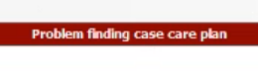

If you attempt to Check out a Patient appointment and receive this error, it means a Care Plan has been deleted out with a Scheduled/Checked Into appointment tied to that Care Plan Data

You will need to Contact Support & Provide:
- Patient Name
- Case Name
- Date of Service that cannot be Checked Out

**To avoid this, you either need to decide to delete the Care Plan before OR after the appt is Completed, not during the process of the patient being Checked Into through Completed in the Appointment Dashboard. Once patient is Checked In, if any data is housed within the Care Plan tab, that appt will try to house that info.

